**Project Report**

**Healthcare Analysis of a Hospital Using Tableau and Cognos with Website Integration Using Bootstrap**

**Contributors:**

1. **Tanmay Narang -20BRS1203-VIT Chennai**
2. **Khushi Pradhan-20BHI10042- VIT Bhopal**

**1. Introduction**

The purpose of this project was to perform a comprehensive healthcare analysis of a hospital using data visualization tools like Tableau and Cognos. The analysis aimed to provide insights into various aspects of the hospital's performance and patient care, including patient demographics, key performance indicators (KPIs), resource utilization, and operational efficiency. The findings were then presented on a website using the Bootstrap framework to ensure a visually appealing and responsive user experience.

**2. Methodology**

The project followed the following methodology:

**a) Data Collection and Preparation**: For this project, the data was obtained from our instructor, who provided a comprehensive dataset containing relevant healthcare information. The dataset encompassed various aspects of the hospital's operations, including patient demographics, medical procedures, billing records, and operational data.:

**b) Analysis and Visualization:** The cleaned and preprocessed data was then imported into Tableau and Cognos, two powerful data visualization tools. Different visualizations and dashboards were created to explore and analyze various aspects of the hospital's performance and healthcare trends. These tools provided an intuitive and interactive platform for data exploration, enabling the project team to derive meaningful insights.

**c) Website Integration Using Bootstrap**: To make the analysis easily accessible and visually appealing, a website was developed to showcase the findings. The Bootstrap framework was employed for website development due to its responsive design, extensive pre-built components, and mobile compatibility. The visualizations and dashboards created in Tableau and Cognos were embedded into the website to allow users to interact with the data and explore the insights.

3. Key Findings and Visualizations The analysis produced several key findings, some of which are highlighted below:

**a) Patient Demographics:**

* Age Distribution: A bar chart displayed the distribution of patients across different age groups, providing insights into the hospital's primary patient population.
* Gender Breakdown: A pie chart showcased the gender distribution among the patients, helping understand the gender-based healthcare needs.

**b) Key Performance Indicators (KPIs):**

* Average Length of Stay: A line chart illustrated the trend of the average length of patient stays over a specific period, enabling the identification of any potential efficiency improvements.
* Patient Satisfaction Scores: A stacked bar chart presented patient satisfaction scores across various dimensions, such as communication, responsiveness, and overall experience.

**c) Resource Utilization:**

* Bed Occupancy Rate: A heat map visualized the utilization of hospital beds over time, allowing the identification of peak periods and potential resource allocation challenges.
* Staffing Ratios: A comparative chart displayed the ratio of healthcare professionals to patients in different departments, facilitating staffing optimization.

**d) Operational Efficiency:**

* Emergency Department Wait Times: A scatter plot showcased the average wait times for patients in the emergency department, enabling the identification of bottlenecks and areas for improvement.
* Surgical Procedure Analysis: A treemap visualized the distribution of different surgical procedures performed at the hospital, helping identify the most common surgeries and their associated outcomes.

**e) Maximum Stays vs. Severity of Illness:**

* Severity of Illness Distribution: A stacked bar chart displayed the distribution of patients across different severity of illness categories, providing insights into the severity levels of patients admitted to the hospital.
* Maximum Stays by Severity: A line chart showcased the maximum length of stay for each severity of illness category, helping identify if patients with higher severity tended to have longer hospital stays.

**f) Maximum Stays by Age Group**:

* Age Group Distribution: A pie chart illustrated the distribution of patients across different age groups, providing insights into the age composition of the hospital's patient population.
* Maximum Stays by Age Group: A bar chart presented the maximum length of stay for each age group, helping identify if certain age groups tended to have longer hospital stays compared to others.

**g) Number of Beds Available by Severity Grade:**

* Severity Grade Distribution: A stacked bar chart displayed the distribution of patients across different severity grades, providing insights into the severity grading of patients admitted to the hospital.
* Number of Beds Available: A bar chart showcased the number of beds available for each severity grade, helping identify the bed capacity allocated to different severity levels.

**h) Maximum Stays by City Code:**

* City Code Distribution: A bar chart displayed the distribution of patients across different city codes, representing the locations from which the patients originated, providing insights into the geographic distribution of patients.
* Maximum Stays by City Code: A line chart showcased the maximum length of stay for each city code, helping identify if patients from certain locations tended to have longer hospital stays compared to others.

The visualizations and findings derived from the analysis provided valuable insights into patient demographics, key performance indicators, resource utilization, operational efficiency, severity of illness, age groups, and geographic distribution. These insights can support evidence-based decision-making, process optimization, and ultimately improve patient care within the hospital.

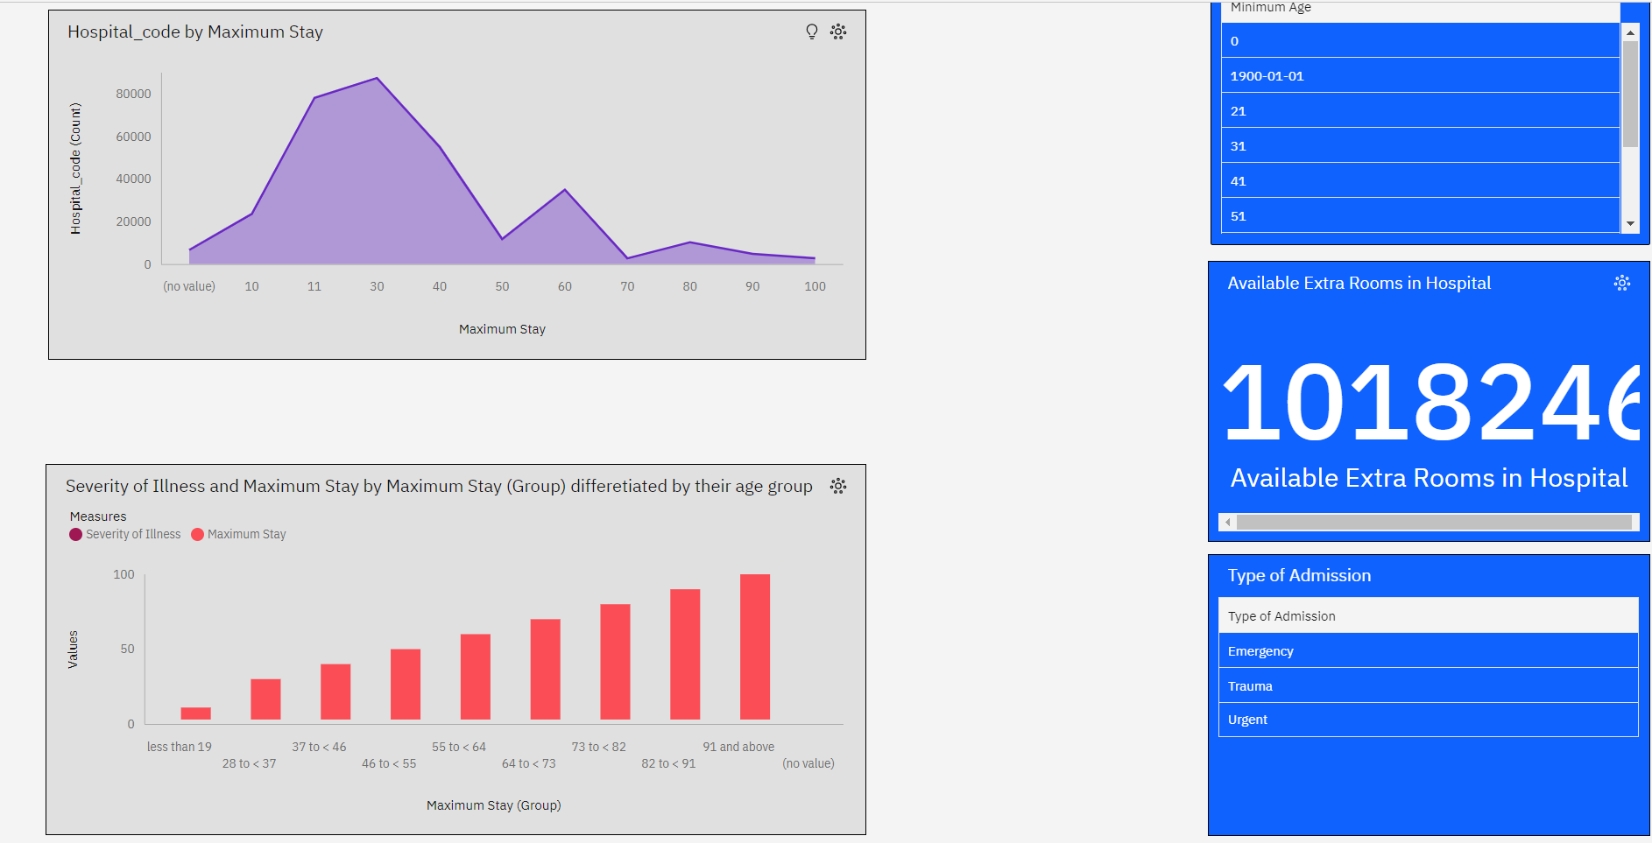

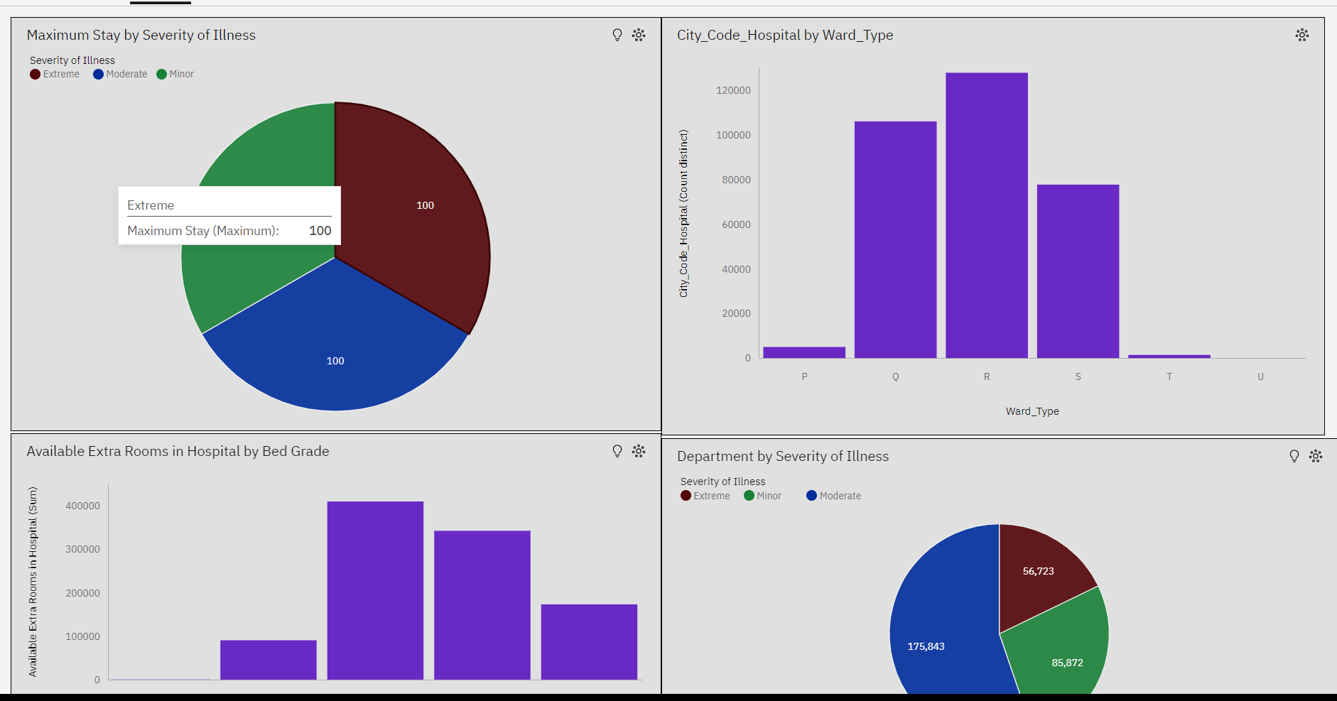

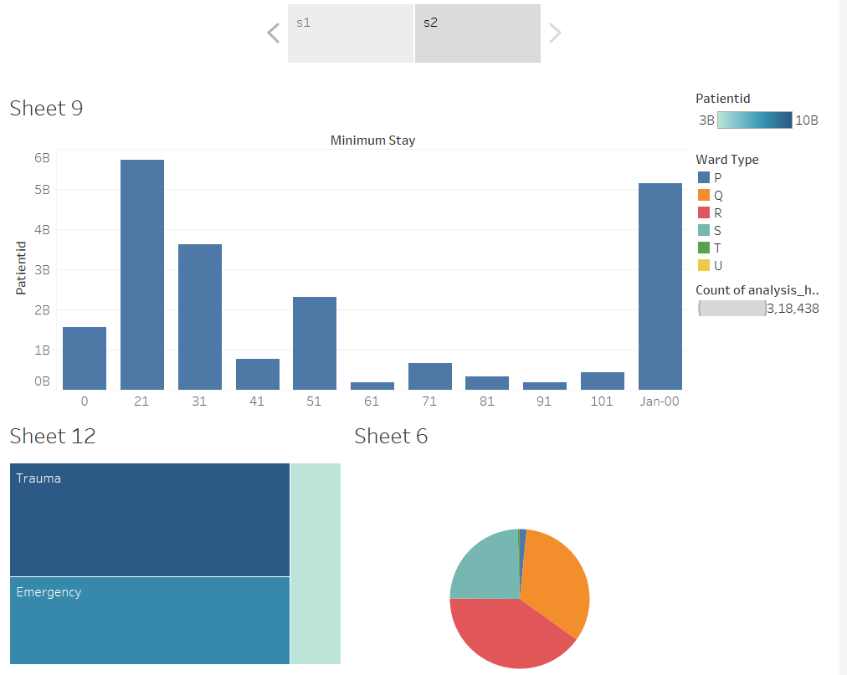

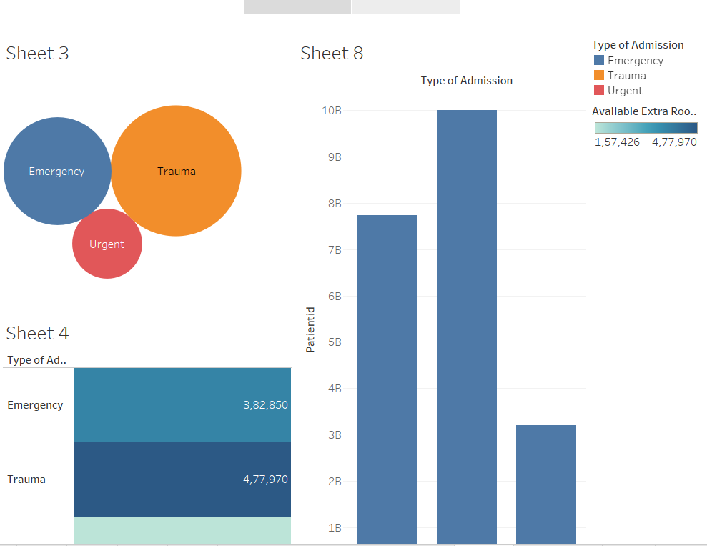

**4. Website Implementation**

The website was implemented using HTML, CSS, and JavaScript with the Bootstrap framework. The Bootstrap grid system and responsive design components were leveraged to ensure optimal viewing across various devices and screen sizes. The Tableau and Cognos visualizations were embedded into the website using their respective integration methods, allowing users to interact with the data and explore the insights seamlessly.

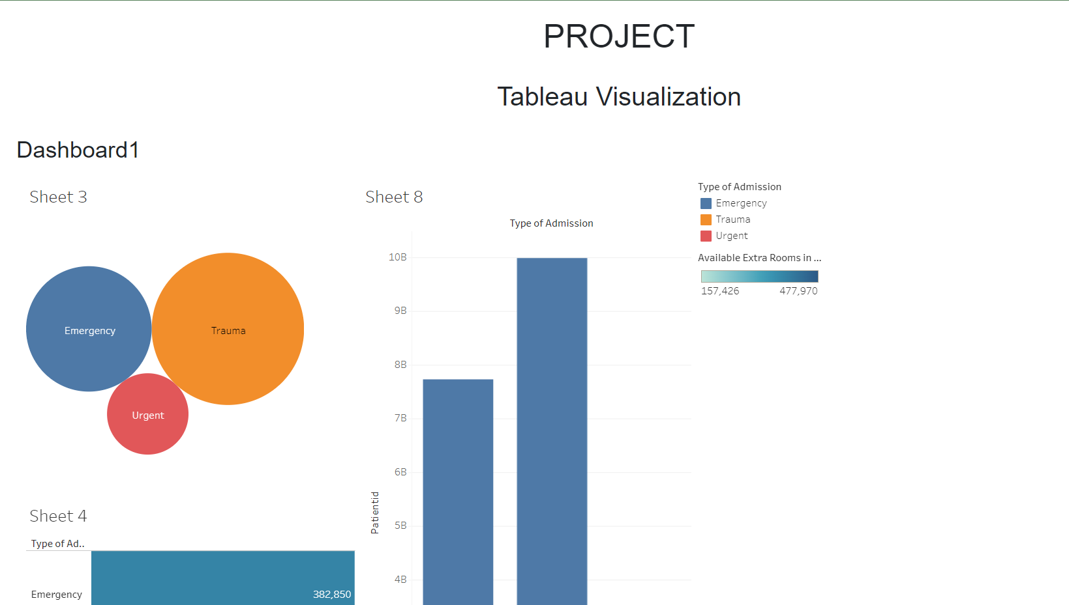

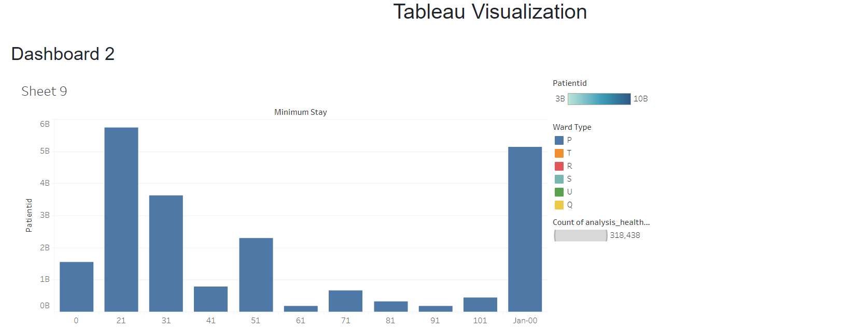

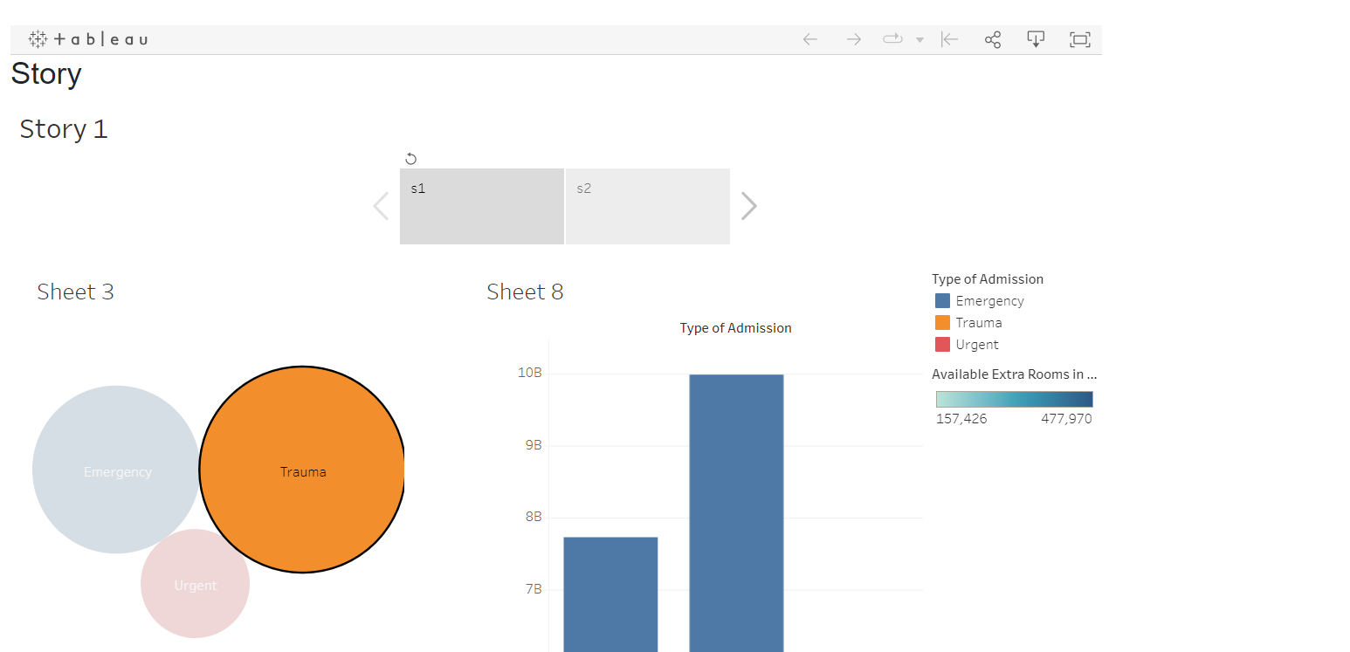

**5. Conclusion**

The project successfully conducted a healthcare analysis of a hospital using Tableau and Cognos, delivering valuable insights into patient demographics, key performance indicators, resource utilization, operational efficiency, severity of illness, age groups, and geographic distribution. The integration of these findings into a website using the Bootstrap framework enhanced accessibility and provided an engaging user experience. The project outcomes can support evidence-based decision-making, process optimization, and ultimately improve patient care within the hospital.

**6. Future Enhancements**

The project can be extended and enhanced in the following ways:

* Real-time Data Updates: Implement mechanisms to update the visualizations and dashboards in real-time, ensuring the latest information is available on the website.
* Predictive Analytics: Integrate predictive models into the analysis to forecast patient volume, resource requirements, and patient outcomes.
* User Feedback: Incorporate user feedback mechanisms within the website to collect suggestions and improvement ideas, enabling iterative enhancements.

By implementing these future enhancements, the hospital can further leverage the power of data visualization and website integration to continually improve its healthcare services and operational efficiency.

Tableau Visualizations

